 

INSTITUTE FOR ADVANCED COMPUTING AND SOFTWARE DEVELOPMENT AKURDI, PUNE

Documentation On

**“ONLINE PARKING SYSTEM”**

e-DAC MAY 2021

*Submitted By:*

**Group No: 43**

**Names: Dhanshree Mohan Sangle Roll no-1050 &**

**Prachi Pradip Kendrekar Roll no -1091**

**Mr.Prashant Karhale Mr.Kashinath Patil**

**Centre Coordinator Project Guide**

# Table of Contents

1. Introduction 1

Document Purpose 2

Problem Statement 2

Product Scope 2

Aim & Objectives 2

1. Overall Description 3

Product Perspective 3

User and Characteristics 3

Operating Environment 3

Design and Implementation Constraints 3

1. Requirements Specification 4

External Interface Requirements 4

3.3 Non-Functional Requirements 12

1. System Diagram 11

Activity Diagram 11

Data Flow Diagram 13

Use Case Diagram 15

ER Diagram 16

1. Table Structure 17

User 17

Parking 17

Booking 17

1. Conclusion 19

Future Scope 19

1. References 20

**List of Figures**

Figure 1 Admin Activity Diagram 11

Figure 2 User Activity Diagram 12

Figure 4 Level 0 Data Flow Diagram 13

Figure 5 Level 1 Data Flow Diagram 13

Figure 6 Level 2 Data Flow Diagram for Admin 14

Figure 7 Level 2 Data Flow Diagram for User 14

Figure 10 Use Case Diagram 16

Figure 11 ER Diagram 16

# Introduction

In Metropolitan areas, most vehicle drivers have the daily concern of finding a vacant parking space especially during Rush hours hence the proposed solution is Online Parking System

It offers a reservation system where user can view various parking spaces and select specific area of their choice to view whether space is available or not. If the booking space is available, then user can book it for specific time slot. User can also view previous parking booking details using the website.

## Document Purpose

The advancement in Information Technology and internet penetration has greatly enhanced various business processes and communication between society owners and their customers who are purchasing the flats. This Society Management System is developed to provide the following services:

Enhance Business Processes:

To be able to use internet technology to project to the global world instead of limiting their services to their local domain alone, thus increase their return on investment (ROI).

Online Parking System:

It offers a reservation system where user can view various parking spaces and select

specific area of their choice to view whether space is available or not. If the

booking space is available, then user can book it for specific time slot. User can

also view previous parking booking details using the website.

## Problem Statement

In Metropolitan areas, most vehicle drivers have the daily concern of finding a vacant parking

Space especially during Rush hours. It takes a lot of time in search of parking space availability

So we proposed the solution of Online Parking system.

## Product Scope

It offers a reservation system where user can view various parking spaces

and select specific area of their choice to view whether space is available or not.

If the booking space is available, then user can book it for specific time slot.

User can also view previous parking booking details using the website.

* Users/Drivers can book parking spaces according to specific city,area,location
* J2EE Technology used for the development of the application.
* Web-platform means that the system will be available for access 24/7 except when there is a temporary server issue which is expected to be minimal.

## Aims & Objectives

Specific goals are: -

* To produce a web-based system that allow the admin to add User and provide functionalities to its role.
* To ease User by providing different functionalities to it.
* Admin can add Parking spaces

# Overall Description

* **III. PROPOSED SYSTEM**

Product functionality:

Online Parking System provides the features for User, Admin. It includes several functionalities

describes as below:

*User:*

It provides facility to Create new user, Sign In,, Login, Logout and book parking spaces as per availability. User can see booking history also User can book parking spaces before arriving.

*Admin:*

The admin can add parking spaces according to city, area and location. Admin can view customer details, view parking, view booking.

## Advantages of Online Parking System

* User can view various parking spaces and select specific area

of their choice

* It saves user time in search of parking space available in specific area.

## Disdvantages of Online Parking System

* It requires Internet connection

## Users and Characteristics:

Admin:

* Admin can login to the system.
* View the list customers/users.
* Add new parking location.
* View parking details
* View booking details

User:

* + User can login to the system.
  + User can create new user.
  + User can change password.
  + User can book parking spaces.
  + Payment.
  + User can update profile.
  + User can see parking history.

## Operating Environment:

Server Side:

**Processor:** Intel® Xeon® processor 3500 series

**HDD:** Minimum 500GB Disk Space

**RAM:** Minimum 2GB **OS:** Windows 10 **Database:** Mysql

Client Side (minimum requirement):

**Processor:** Intel Dual Core

**HDD:** Minimum 80GB Disk Space

**RAM:** Minimum 1GB

**OS:** Windows 7, Linux

## Design and Implementation Constraints:

* The application will use React as Frontend and Spring boot ,MySQL as backend
* HTTP and FTP protocols are used as communication protocols. FTP is used to upload the web application in live domain and the client can access it via HTTP protocol.
* Several types of validations make this web application a secured one and SQL Injections can also be prevented.
* Since Online Parking system is a web-based application, internet connection must be established.
* The Online Parking System will be used on PCs and will function via internet or intranet in any web browser.

# Specific Requirement

## External Interface Requirements:

User Interfaces:

* + All the users will see the same page when they enter in this website. This page asks the users a username and a password.
  + After being authenticated by correct username and password, user will be redirect to their corresponding profile where they can do various activities.
  + The user interface will be simple and consistence, using terminology commonly understood by intended users of the system. The system will have simple interface, consistence with standard interface, to eliminate need for user training of infrequent users.

Hardware Interfaces:

* + No extra hardware interfaces are needed.
  + The system will use the standard hardware and data communication resources.
  + This includes, but not limited to, general network connection at the server/hosting site, network server and network management tools.

Application Interfaces:

**OS:** Windows 10

**Web Browser:**

The system is a web-based application; clients need a modern web browser such as Mozilla Firebox, Internet Explorer, Opera, and Chrome. The computer must have an Internet connection in order to be able to access the system.

Communications Interfaces:

* + This system uses communication resources which includes but not limited to, HTTP protocol for communication with the web browser and web server and TCP/IP network protocol with HTTP protocol.
  + This application will communicate with the database that holds all the booking information. Users can contact with server side through HTTP protocol by means of a function that is called HTTP Service. This function allows the application to use the data retrieved by server to fulfil the request fired by the user.

# System Design

## Activity Diagram

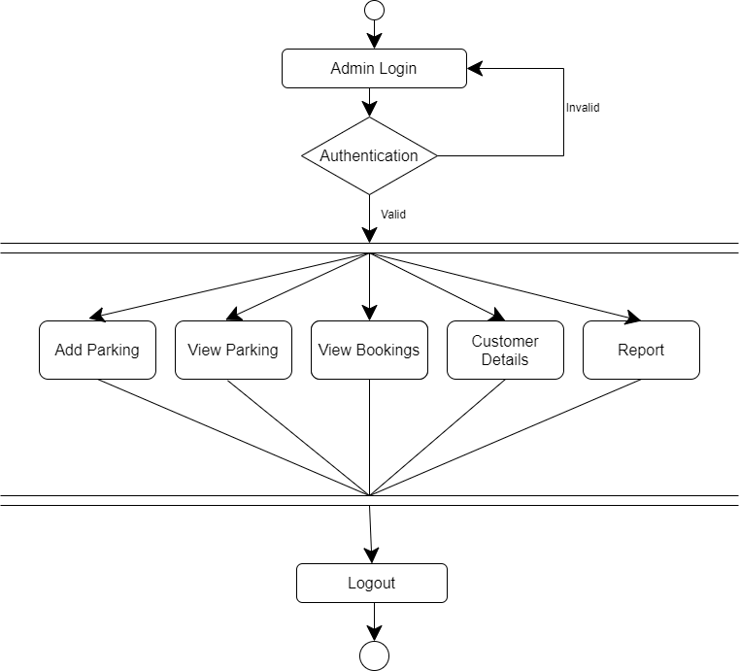

**Figure 1: Admin Activity Diagram**

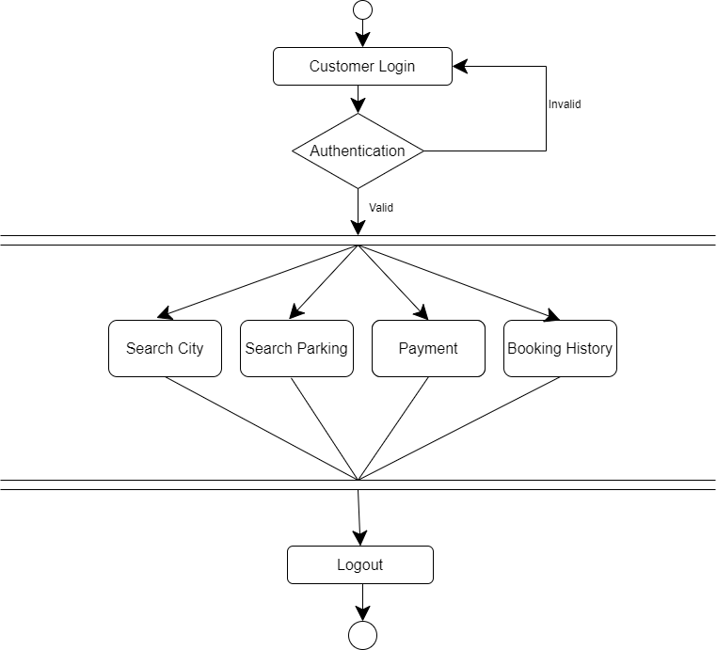

**Figure 2User Activity Diagram**

## Data Flow Diagram

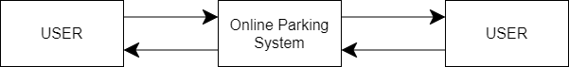

**Figure 4: Level 0 Data Flow Diagram**

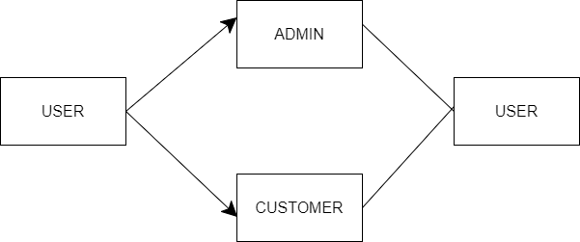

**Figure 5: Level 1 Data Flow Diagram**

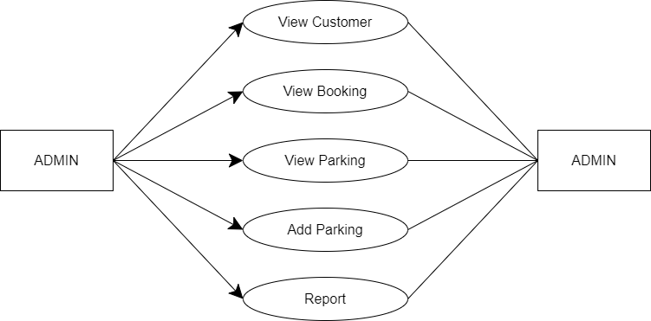

**Figure 6: Level 2 Data Flow Diagram for Admin**

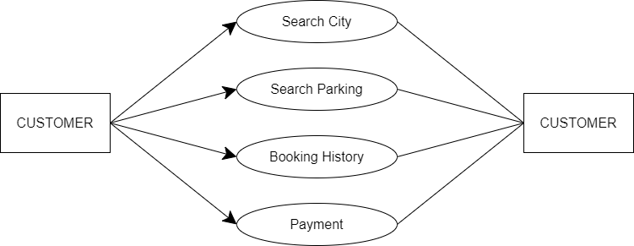

**Figure 7: Level 2 Data Flow Diagram for Customer**

## Use Case Diagram

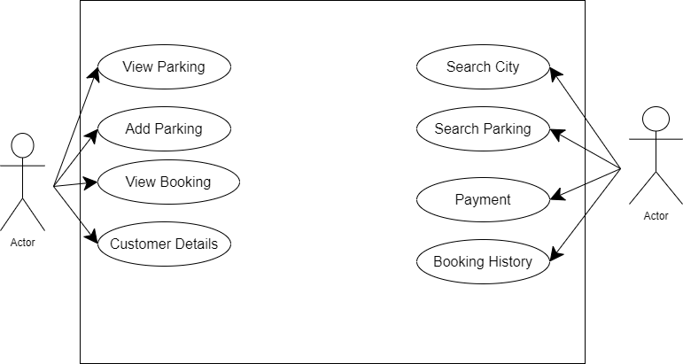

**Figure 10: Use Case Diagram**

## ER Diagram

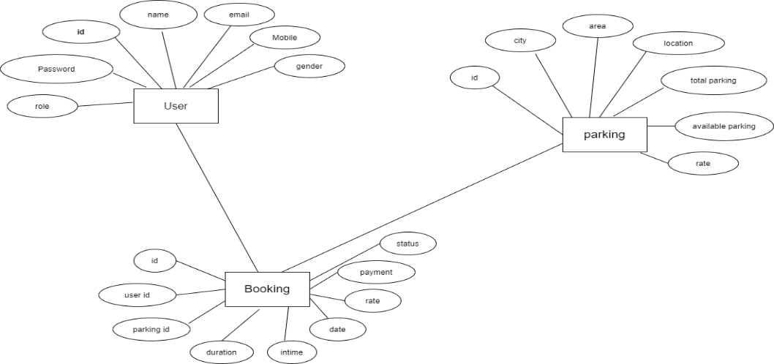

# Table Structure

## User table:

|  |  |  |  |  |  |
| --- | --- | --- | --- | --- | --- |
| Field | Type | Null | Key | Default | Extra |
| U_id | Int | No | PRI | NULL | Auto_increment |
| Email | varchar(255) | Yes | UNI | NULL |  |
| Gender | varchar(255) | Yes |  | NULL |  |
| Mob | varchar(255) | Yes | UNI | NULL |  |
| U_pass | varchar(255) | Yes |  | NULL |  |
| pass | varchar(255) | Yes |  | NULL |  |
| role | varchar(255) | yes |  | NULL |  |

## Parking Table

|  |  |  |  |  |  |
| --- | --- | --- | --- | --- | --- |
| Fields | Type | Null | Key | Default | Extra |
| Park_id | Int | NO | PRI | NULL | Auto_increment |
| Area | Varchar(255) | YES |  | NULL |  |
| Avail_parking | Int | NO |  | NULL |  |
| City | Varchar(255) | YES |  | NULL |  |
| Location | Varchar(255) | YES |  | NULL |  |
| Rate | Double | NO |  | NULL |  |
| Total_parking | int | NO |  | NULL |  |

## Booking Details:

|  |  |  |  |  |  |
| --- | --- | --- | --- | --- | --- |
| Fields | Type | Null | Key | Default | Extra |
| Booking_id | Int | NO | PRI | NULL | Auto_increment |
| Date | Date | YES |  | NULL |  |
| Duration | Int | YES |  | NULL |  |
| Intime | Time | YES |  | NULL |  |
| Parkingid | Int | YES |  | NULL |  |
| Payment | Int | YES |  | NULL |  |
| Rate | Int | YES |  | NULL |  |
| Status | Int | YES |  | NULL |  |
| Userid | Int | YES |  | NULL |  |

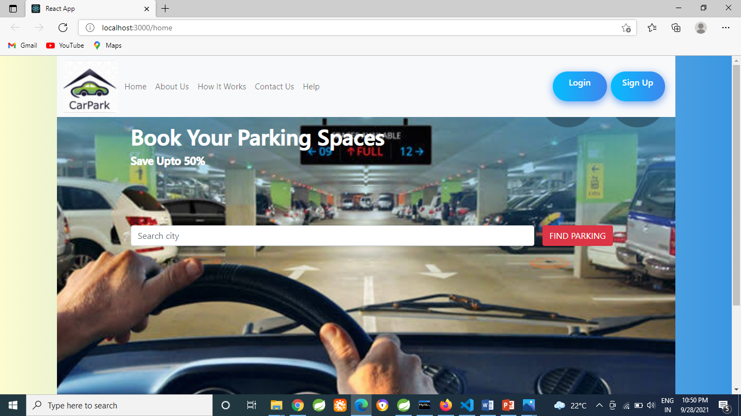

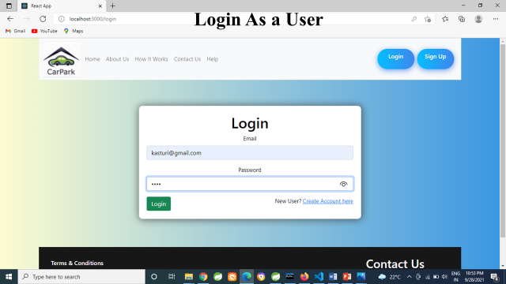

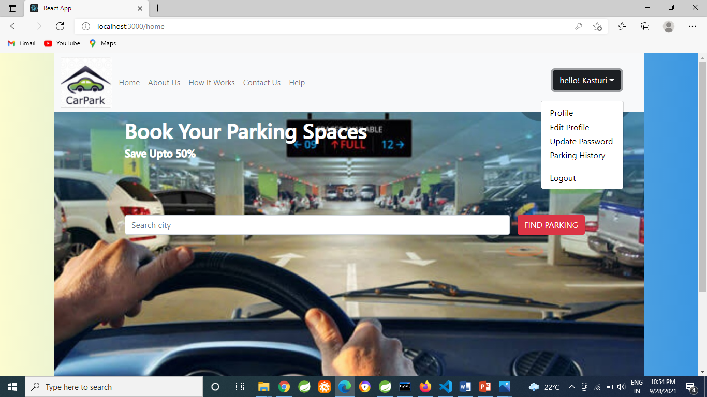

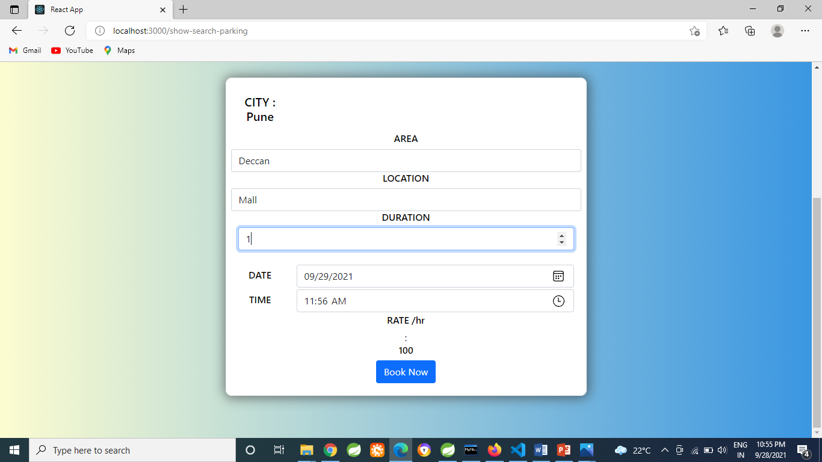

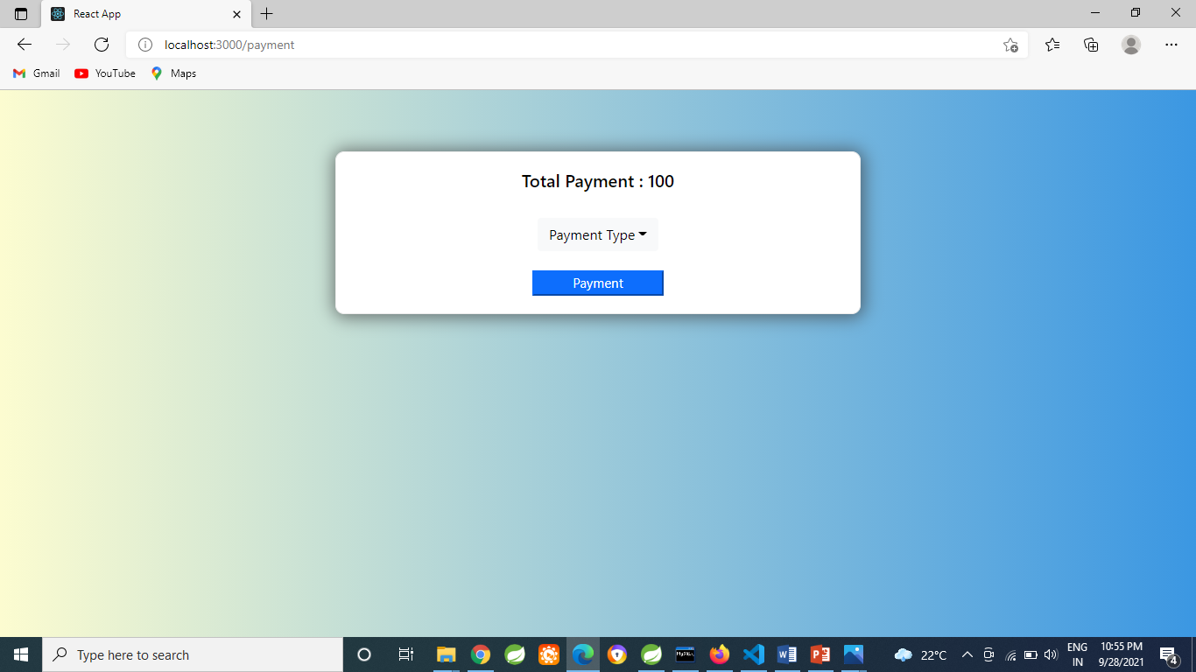

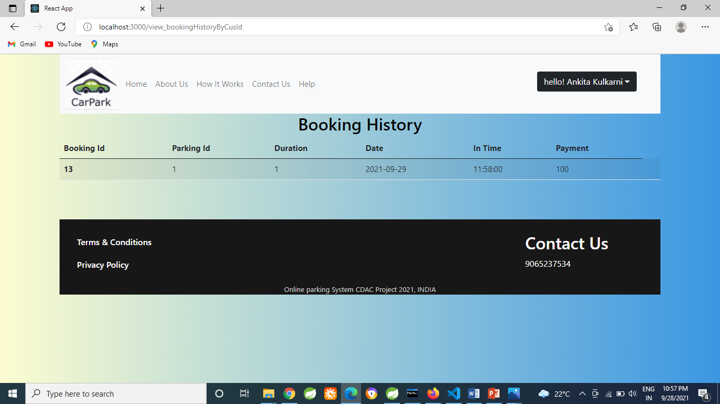

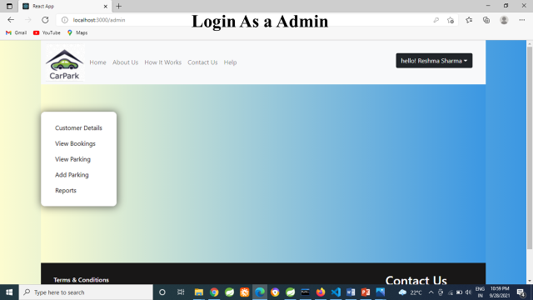

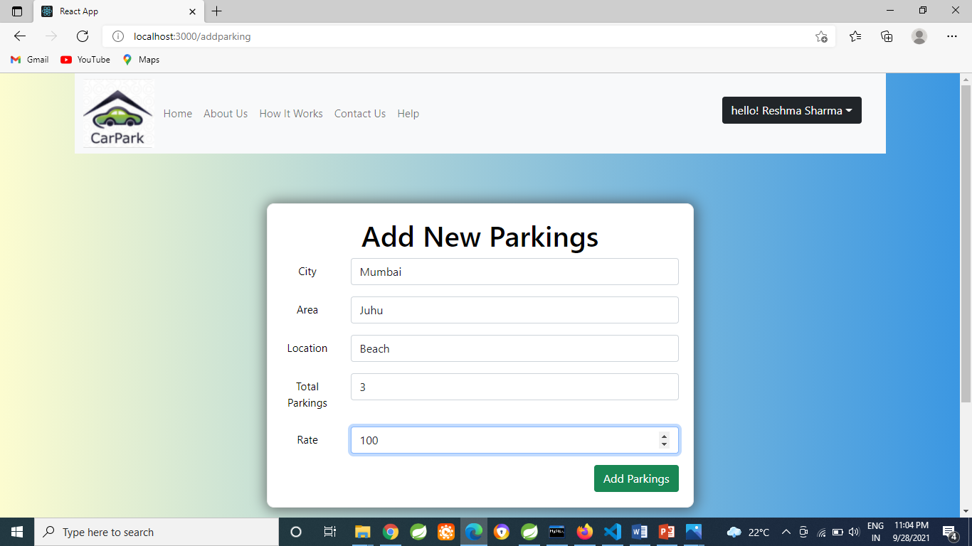

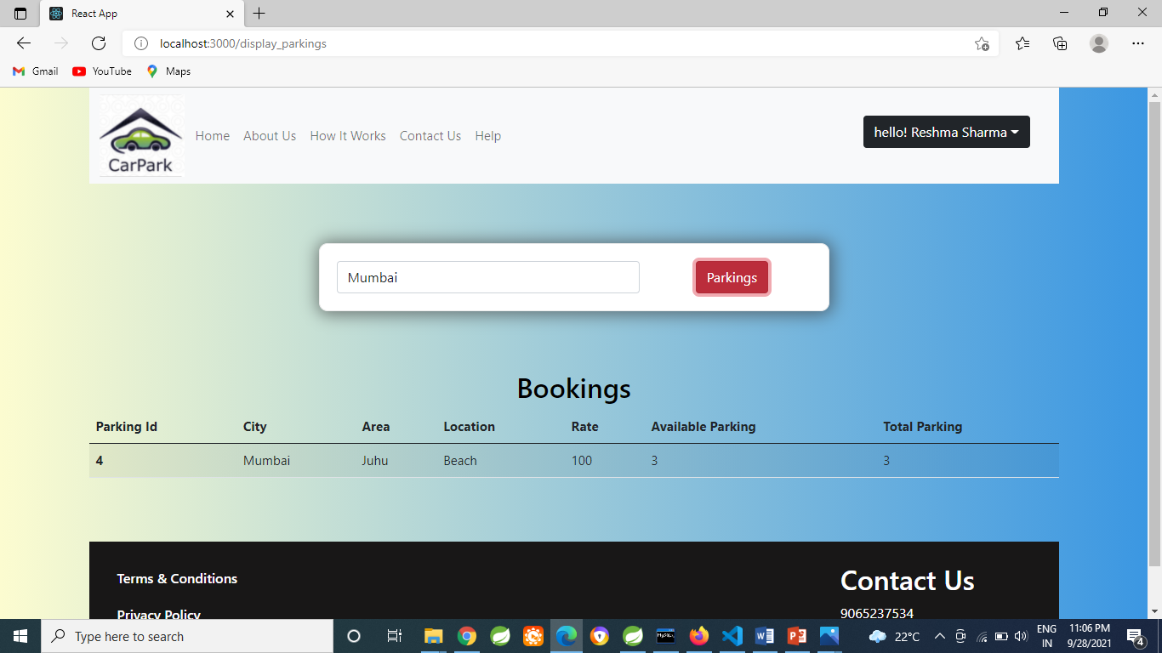

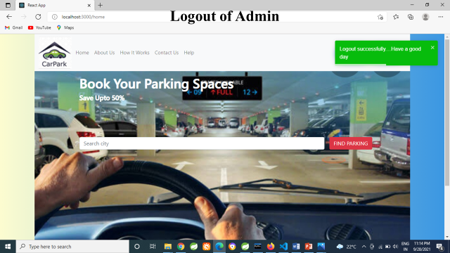

# Conclusion

* The difficulty of searching available parking spaces has been completely eliminated by reserving Parking spaces via proposed system

# Future Scope

This project can be enhanced further by adding notify available spaces, online payment options. The software is flexible enough to be modified and implemented as per future requirements.

**ONLINE REFERENCE**

1. <https://w3schools.com/>
2. <https://stackoverflow.com/questions/43665090>